Sets of Integers

Workshop #2

Flutter Developer Bootcamp

# **Purpose**

This workshop demonstrates the basic set operations in Dart programming language using sets.It also illustrates how to perform basic set operations such as union, intersection, and difference using Dart sets. It provides a simple example to understand how these operations work with sets and how to use corresponding methods provided by Dart's Set class.

# **Problem**

In the given workshop, there will be two sets of integers set1 and set2(set1 contains integers {1, 2, 3, 4, 5} and set2 contains integers {3, 4, 5, 6, 7} and it also have union and intersection of sets. You need to find the difference of sets(set1 and set2).

# **How to Solve**

1. Checkout the workshop from Git Repo:

git clone -b <user-branch> <repo-URL>

1. Open the root folder inside VS Code
2. Open the root folder in terminal
3. Run the command dart run filename.dart
4. Find the difference of set 1 and set2.
5. Go To File: <specific-file-with-set-method> à <method-name>, implement your set logic.

**You will Achieve**

When you complete this workshop you will learn the following:

* **Set Creation:**

Two sets of integers (set1 and set2) are defined using set literals. Each set contains a collection of integers.

* **Printing Sets:**

The content of both sets is printed using print() statements.

* **Set Operations:**
* **Union:** The union method is used to compute the union of set1 and set2. This method returns a new set containing all unique elements from both sets.
* **Intersection:** The intersection method is used to compute the intersection of set1 and set2. This method returns a new set containing elements that are common to both sets**.**
* **Difference:** The difference method is used to compute the difference between set1 and set2. This method returns a new set containing elements that are present in set1 but not in set2.
* **Printing Results:**

The results of each set operation (union, intersection, and difference) are printed using print() statements.

* So, it demonstrates how to use set operations such as union, intersection, and difference in Dart using the union(), intersection(), and difference() methods provided by the Set class. It showcases basic set manipulation and provides a clear output to visualize the results of each operation.

# **Screenshots**

## **Before implementation (without finding difference of sets of integers )**

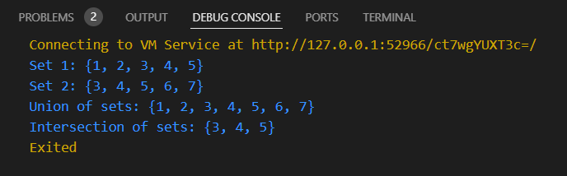

## **After implementation (With finding the difference of sets of integers)**

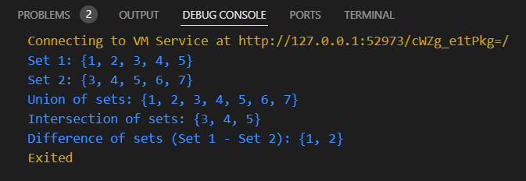

# **How to submit your workshop**

Push your project back to the same git branch using command:

<command name>

# **Happy Coding!**